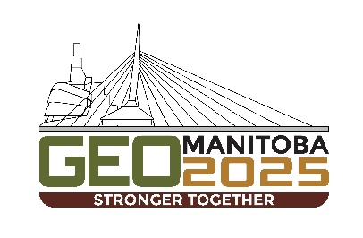
Title – formatting guidelines for authors submitting extended abstracts to GeoManitoba 2025

Author One, Author Two, & Author Three
Company Name, City, Province/State, Country
Author Four, Author Five, & Author Six
Department of XX – University of YY, City, Province/State, Country

ABSTRACT
Extended abstracts may be submitted in English or French based on the original abstract submitted and accepted. To ensure consistency in the presentations of the extended abstracts in the digital proceedings, your extended abstract must conform to this template. We suggest that extended abstracts be limited to a maximum of 2 pages. All extended abstracts must be submitted via the on-line submission page on the GeoManitoba 2025 website by April 30, 2025.

Please ensure that you spell check your document and review it for correct grammatical English and French. The extended abstracts will be formally peer reviewed by the GeoManitoba 2025 Technical Committee for scientific correctness or to ensure adequate spelling/grammar. All presenting authors must be registered as full conference delegates (or students, if applicable) to submit an extended abstract.

